Version 1.1

Revision History

|  |  |  |  |
| --- | --- | --- | --- |
| **Date** | **Version** | **Description** | **Author** |
| 09/24/2013 | 1.0 | Initial Requirements | Matthew, David, Lauren, Rico |
| 10/10/2013 | 1.1 | Added Class, E-R, Statecharts, and Sequence Diagrams | Matthew, David, Lauren, Rico |
|  |  |  |  |
|  |  |  |  |

Table of Contents

1. Document Overview 4

1.1 Purpose 4

1.2 Document Conventions 4

1.3 References 4

2. Project Mission Statement 4

2.1 Project Introduction 4

2.2 Product Vision and Scope 4

2.3 Stakeholders 4

2.4 Assumptions and Constraints 4

2.5 Business Requirements 4

3. Requirements 4

3.1 Functionality 4

3.1.1 Start New Game 4

3.1.2 Play Game 4

3.1.3 End Game in Progress 5

3.1.4 Add Level 5

3.1.5 Update Level 5

3.1.6 Delete Level 5

3.2 Non-functional Requirements 5

3.3 Performance Requirements 5

3.4 Security Requirements 5

3.5 Software Quality Attributes 5

3.6 Supplementary Requirements 5

4. Classification of Functional Requirements 6

5. Use Cases 7

6. Class Diagram 8

7. E-R Diagrams 9

8. Statechart 10

9. Sequence Diagrams 11

9.1 Start New Game 11

9.2 Play Game 12

9.3 End Game in Progress 12

9.4 Add Level 13

9.5 Update Level 14

9.6 Delete Level 15

10. Appendices 16

Appendix A: Project Glossary 16

# Document Overview

## Purpose

The purpose of this document is to detail the requirements and specifications, in order for the client to better understand the project. This document contains a list of all information relevant to the project.

## Document Conventions

None

## References

WebMd Sensory Processing Disorder - <http://www.webmd.com/parenting/sensory-processing-disorder>

# Project Mission Statement

## Project Introduction

The sorting game will help children with Sensory Processing Disorder. Children with SPD will often become over stimulated in situations where there is a lot of activity going on, causing them to get very hyperactive and jittery. This makes essential activities, such as learning in a classroom setting, very difficult for the child. The sorting game will give them an opportunity to channel their energy in a positive way. The sorting game will allow them to add their own levels and categories, so the game can be tailored to the specific child’s needs. The player can upload their own images, which gets the child more involved and interested in the game. This feature is an improvement over current games, which do not allow the game to be customized to the child's needs.

## Product Vision and Scope

The sorting game will provide a positive outlet for children with Sensory Processing Disorder. The game will be designed for children with SPD but not limited to them exclusively. Any child can play and enjoy the game.

## Stakeholders

Primarily children with Sensory Processing Disorder, but other children will enjoy and benefit from the game.

## Assumptions and Constraints

This project assumes the user has adequate skills and experience using an Android device.

Software Constraints: Android version 2.2 or later

Hardware: Android device with or without a camera

## Business Requirements

The goal of this project is to help children with Sensory Processing Disorder. The sorting will be customizable so that it can be modified to a child's specific needs and interests.

# Requirements

## Functionality

### Start New Game

The player will select which level to play and the device loads the data for the selected level.

### Play Game

The player chooses an image from the item pool and drags it to one of the available categories. If the category chosen is the correct one, the image will stay where it is placed. If the image is placed in an incorrect category, it will automatically return to the item pool.

### End Game in Progress

If the player tries to exit a game in process using the exit button, back button, home button, etc, the player will be prompted to save the current progress. If they choose to save, then the machine will save the game’s current state. It the player chooses not to save, the game will exit without saving.

### Add Level

The player pushes the add level button to create a new level. They will define the level name and begin to add new categories. They will define the categories and upload their own images via the device’s camera or the photo gallery. The player will then assign each image to one of the defined categories and select save to store the new level.

### Update Level

The player will press the update level button. The player can then make changes to the level name, categories, and images.

### Delete Level

The player pushes the delete level button. The player then selects which level or levels they want to delete. They then press the delete button and the device deletes the level data.

## Non-functional Requirements

## Performance Requirements

The user’s device should be capable of running Android version 2.2 at minimum to use this application. There will also be optional use of camera. The user will have the ability to take photos with the camera built into their android device and implement them into the game.

## Security Requirements

None

## Software Quality Attributes

This application will be self-maintainable. The user will be able to update and make changes to levels and categories as they please.

## Supplementary Requirements

None

# Classification of Functional Requirements

|  |  |
| --- | --- |
| **Functional Requirement** | **Priority** |
| Start New Game | Essential |
| Play Game | Essential |
| End Game in Progress | Essential |
| Add Level | Desirable |
| Update Level | Desirable |
| Delete Level | Desirable |

# Use Cases

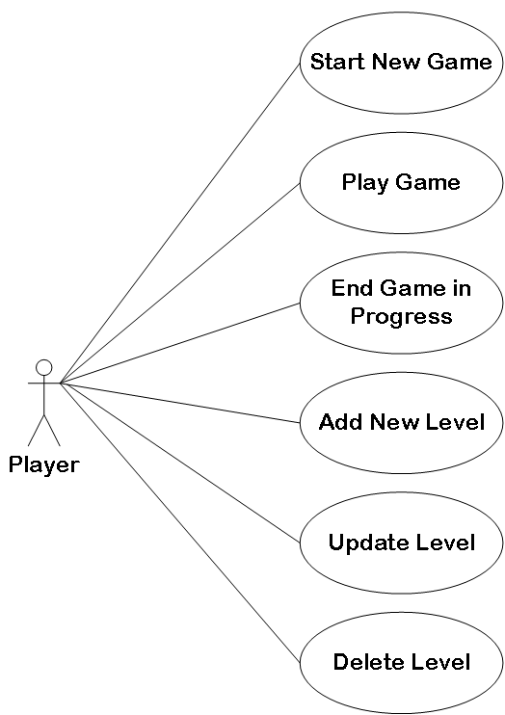

# Class Diagram

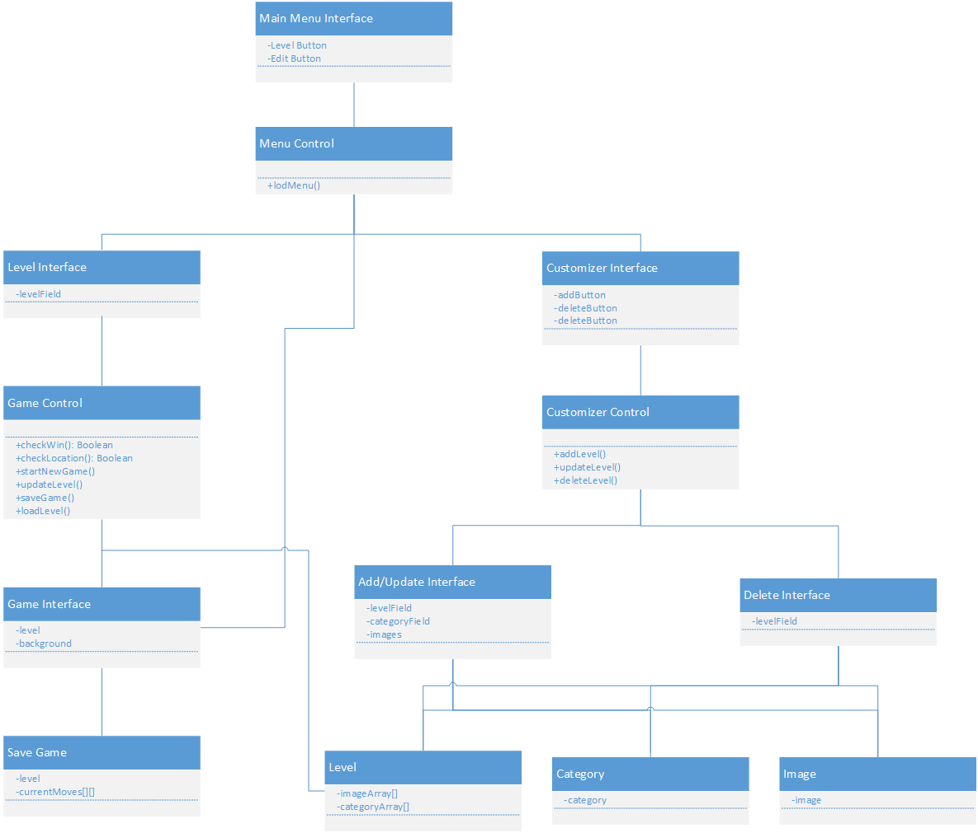

# E-R Diagrams

|  |  |
| --- | --- |
| Level Database | Save Level Database |
|  |  |

# Statechart

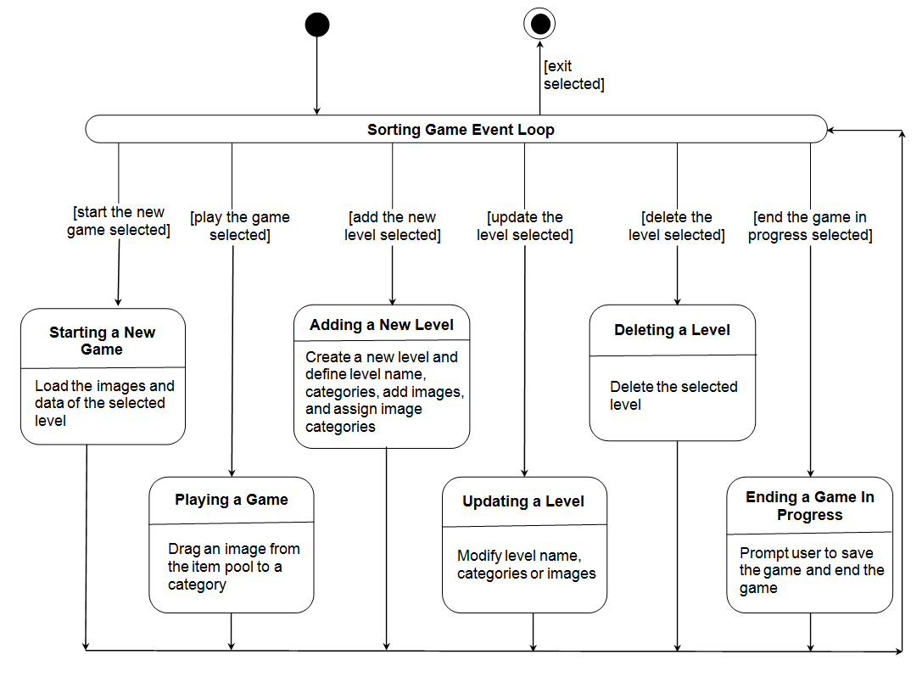

# Sequence Diagrams

## Start New Game

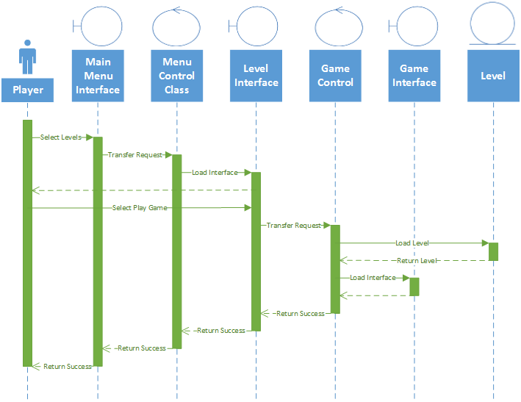

## Play Game

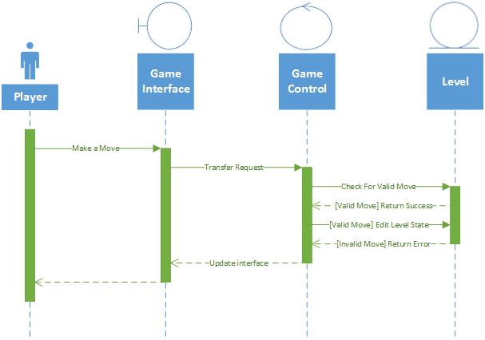

## End Game in Progress

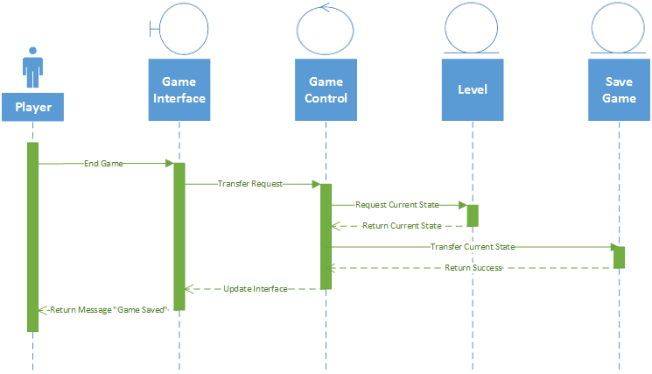

## Add Level

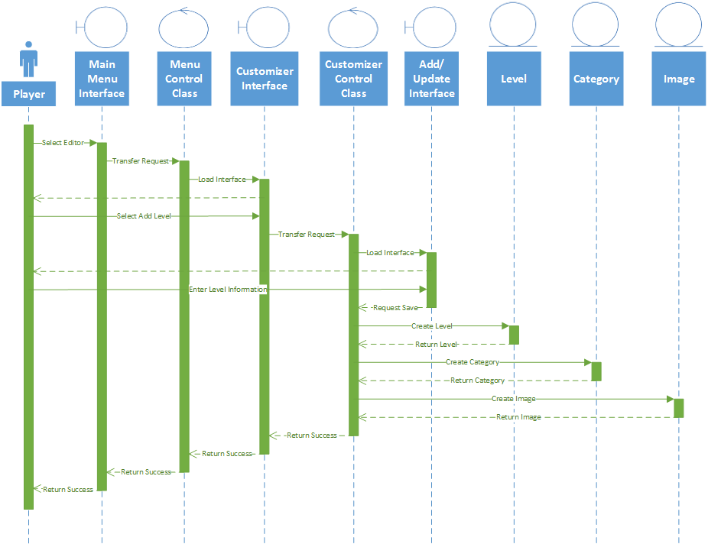

## Update Level

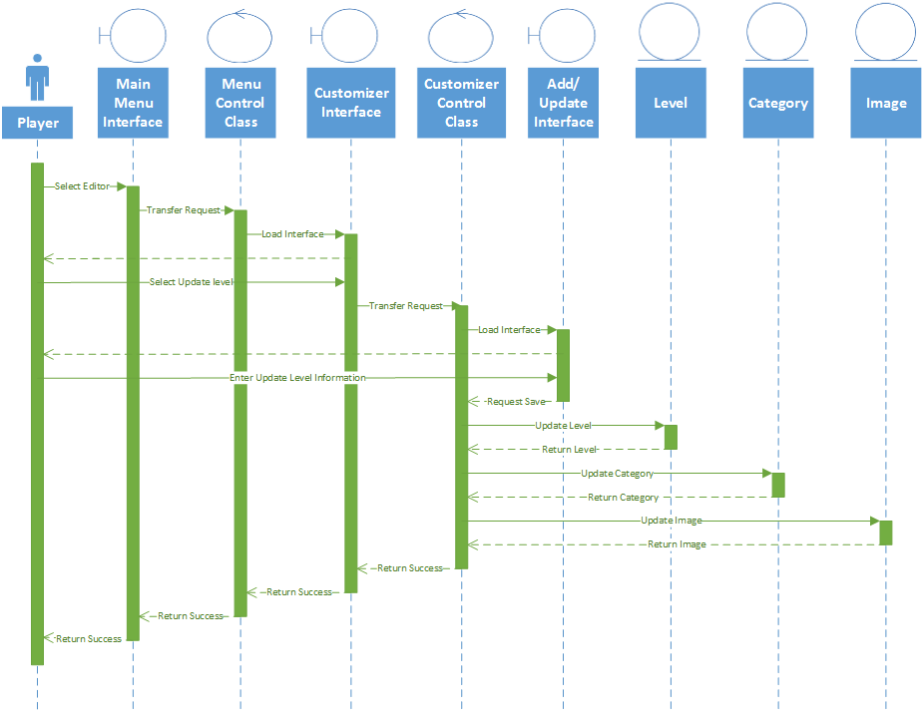

## Delete Level

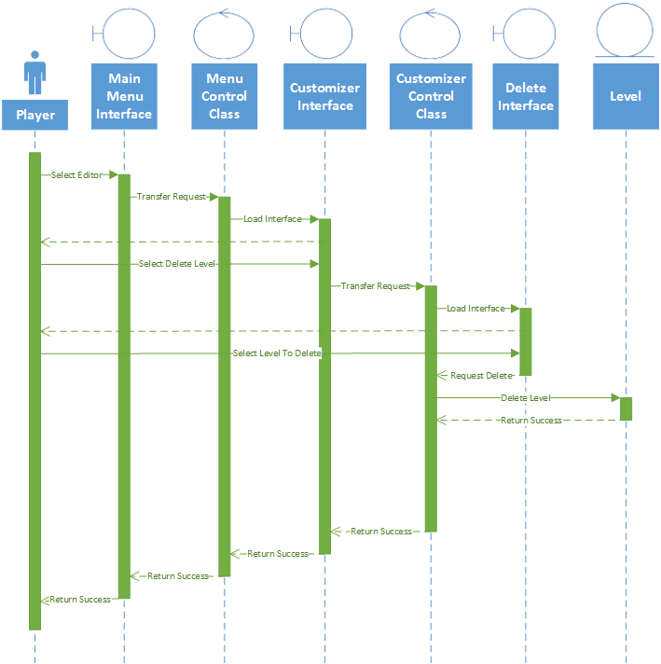

# Appendices

## Appendix A: Project Glossary

* + Sensory Processing Disorder (SPD)
    - A condition in which the brain has trouble receiving and responding to information that comes in through the senses (WebMD).
  + Category
    - A pre-defined group for the images to be sorted into.
  + Object
    - The items to be sorted into the categories. A specific color, shape, picture etc…
  + Level
    - An individual instance of the game, to be played by the user.
  + Android
    - A Linux-based operating system primarily used on handheld touch screen devices.